OOP Lab: Experiment 4

Submitted By: Aryan Saxena

Batch: B1

SAP Id: 500082431

Roll No.: R214220274

**Exercise 1:** Write a Java program to show that private member of a super class cannot be accessed from derived classes.

Code:

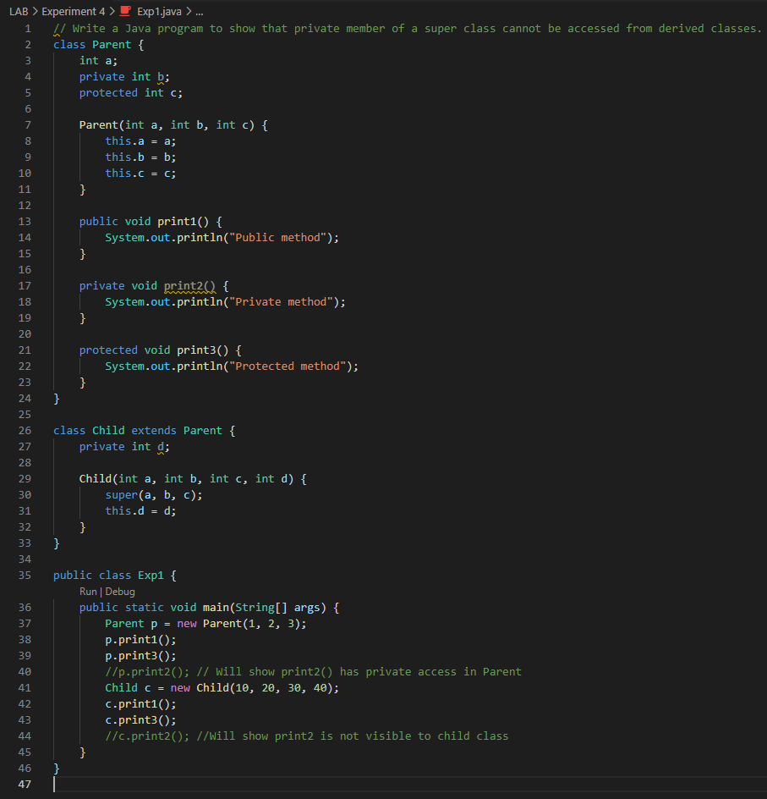

## Output:

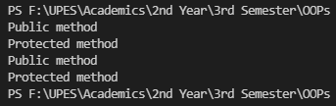

***OUTPUT with Error-* The program takes care of repetition if digits are repeated**

Windows PowerShell

Copyright (C) Microsoft Corporation. All rights reserved.

Try the new cross-platform PowerShell https://aka.ms/pscore6

PS F:\UPES\Academics\2nd Year\3rd Semester\OOPs Theory\sem3-Java-OOP> cd "f:\UPES\Academics\2nd Year\3rd Semester\OOPs Theory\sem3-Java-OOP\LAB\Experiment 4\" ; if ($?) { javac Exp1.java } ; if ($?) { java Exp1 }

Exp1.java:40: error: print2() has private access in Parent

p.print2(); // Will show print2() has private access in Parent

^

Exp1.java:44: error: cannot find symbol

c.print2(); //Will show print2 is not visible to child class

^

symbol: method print2()

location: variable c of type Child

2 errors

PS F:\UPES\Academics\2nd Year\3rd Semester\OOPs Theory\sem3-Java-OOP\LAB\Experiment 4>

**Exercise 2:** Write a program in Java to create a Player class. Inherit the classes Cricket _Player, Football _Player and Hockey_ Player from Player class.

## Code:

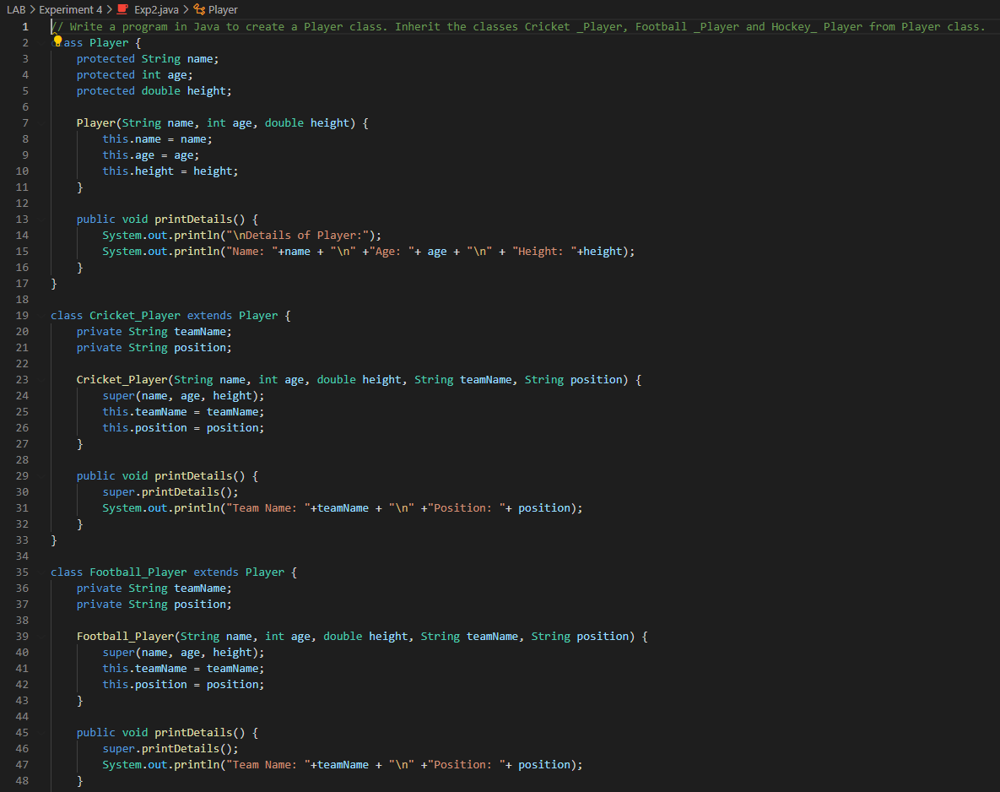

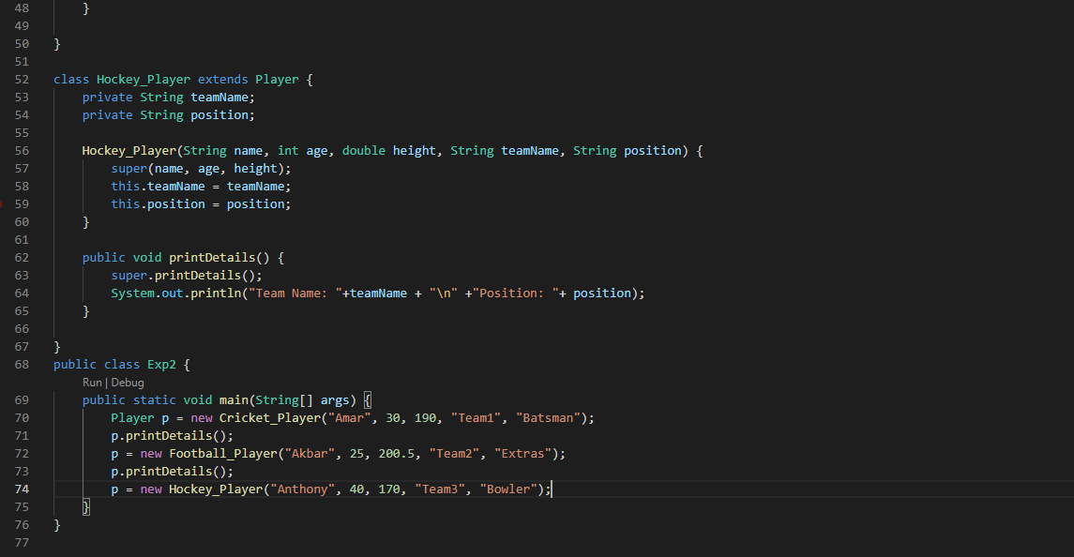

## Output:

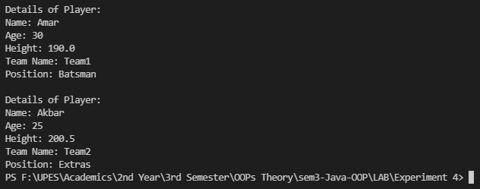

**Exercise 3:** Write a class Worker and derive classes DailyWorker and SalariedWorker from it. Every worker has a name and a salary rate. Write method ComPay (int hours) to compute the week pay of every worker. A Daily Worker is paid on the basis of the number of days he/she works. The Salaried Worker gets paid the wage for 40 hours a week no matter what the actual hours are. Test this program to calculate the pay of workers. You are expected to use the concept of polymorphism to write this program.

## Code:

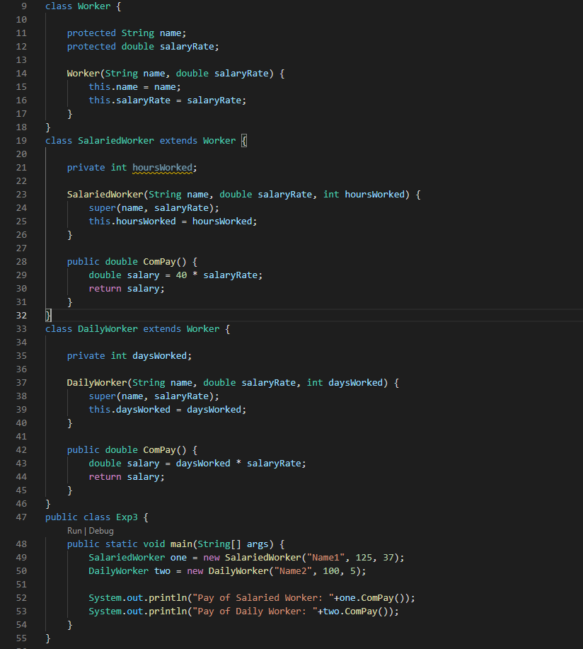

## Output:

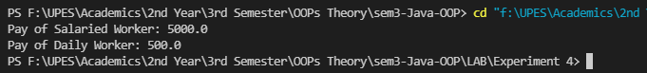

**Exercise 4:** Consider the trunk calls of a telephone exchange. A trunk call can be ordinary, urgent or lightning. The charges depend on the duration and the type of the call. Write a program using the concept of polymorphism in Java to calculate the charges.

## Code:

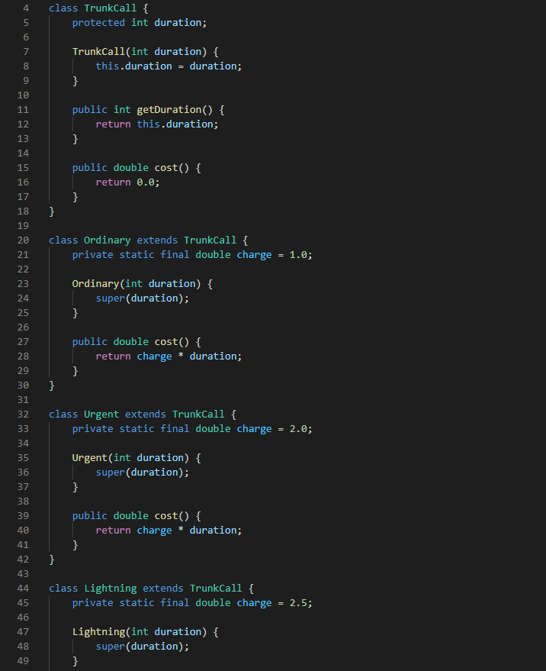

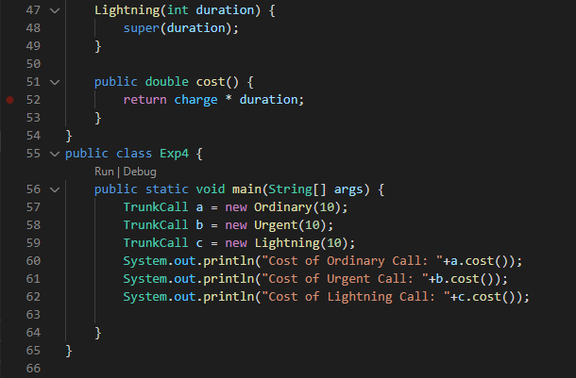

## Output:

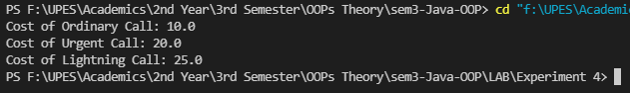

**Exercise 5:** Design a class employee of an organization. An employee has a name, empid, and salary. Write the default constructor, a constructor with parameters (name, empid, and salary) and methods to return name and salary. Also write a method increaseSalary that raises the employee’s salary by a certain user specified percentage. Derive a subclass Manager from employee. Add an instance variable named department to the manager class. Supply a test program that uses theses classes and methods.

## Code:

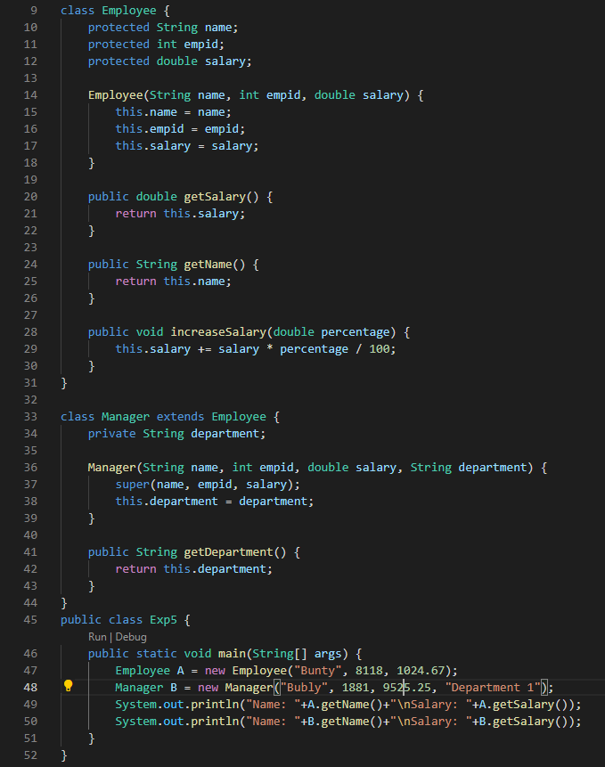

## Output:

